This is my survey google form Question

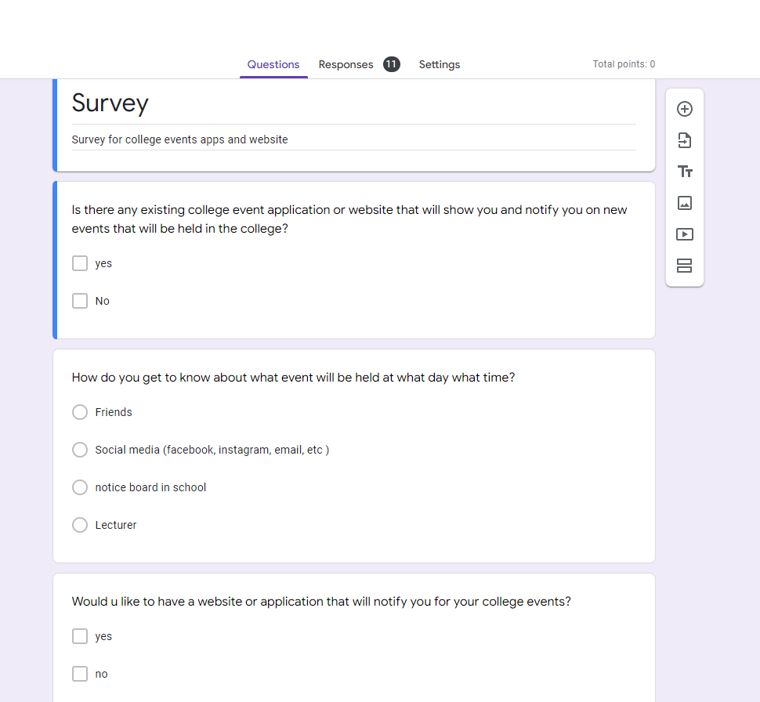

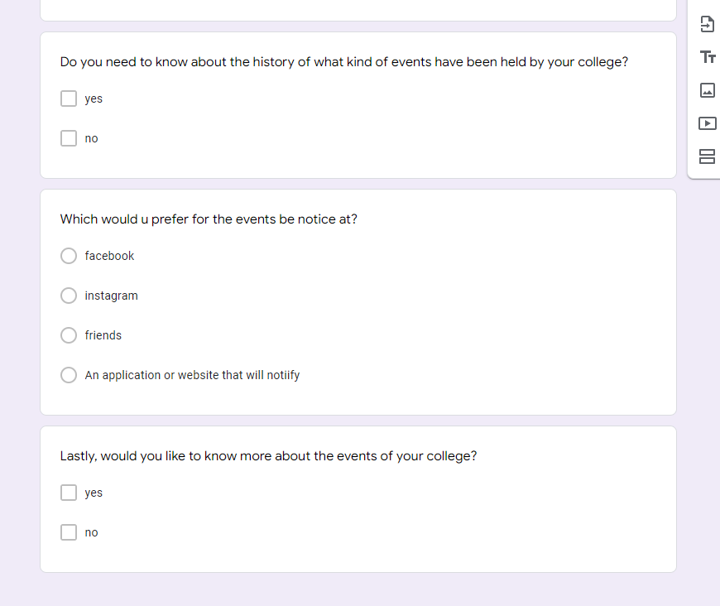

This is my number of respondent and the summary of all question

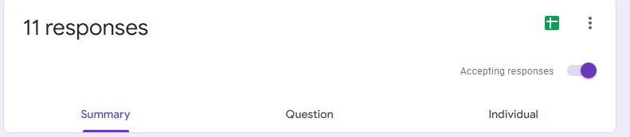

Q1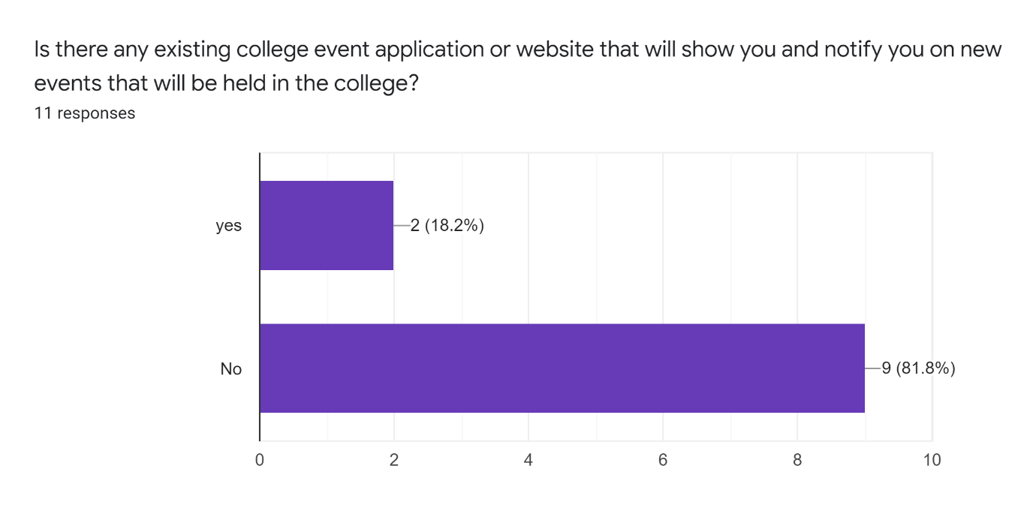

Q2

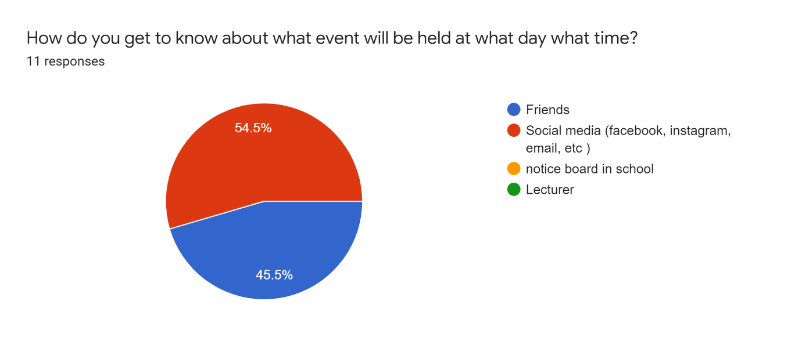

Q3

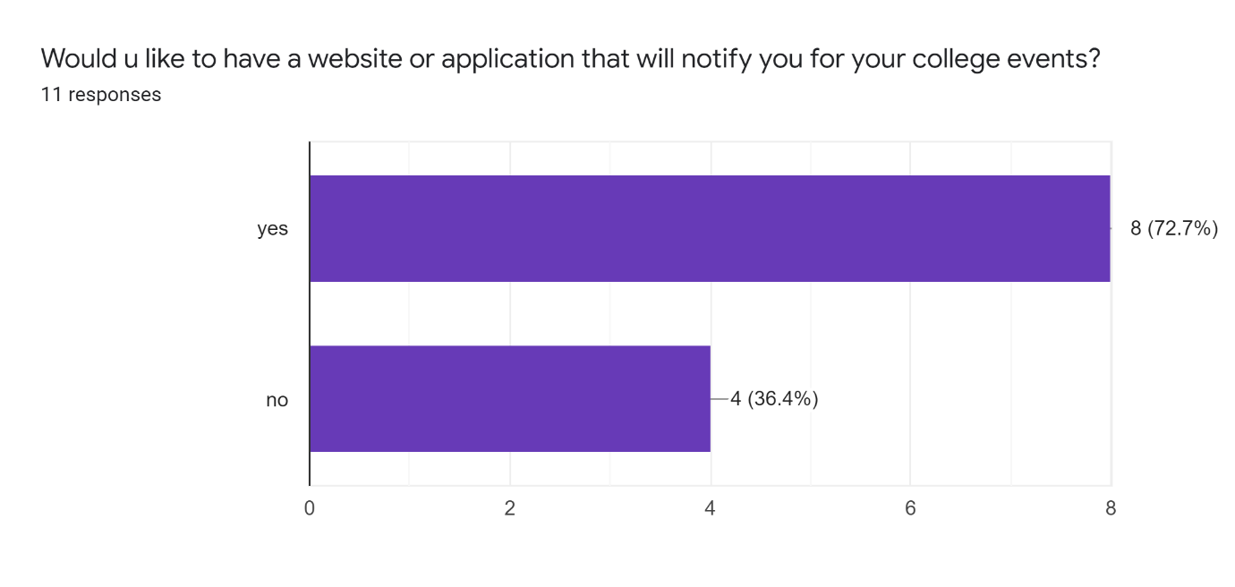

Q4

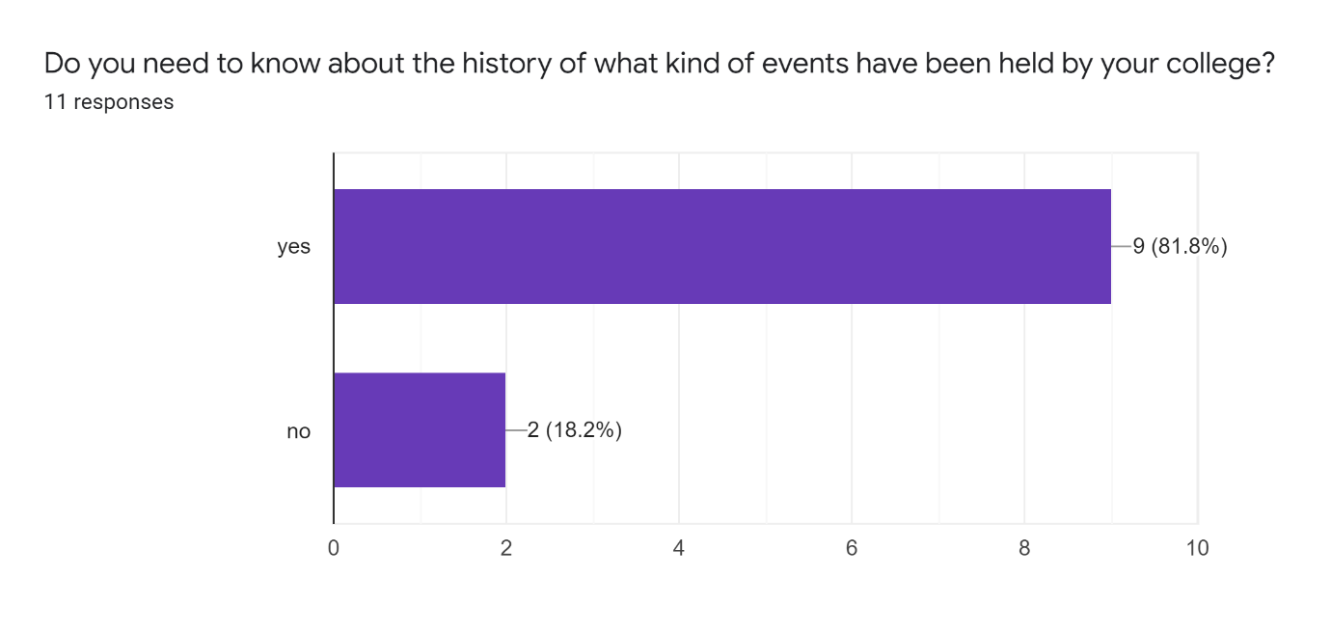

Q5

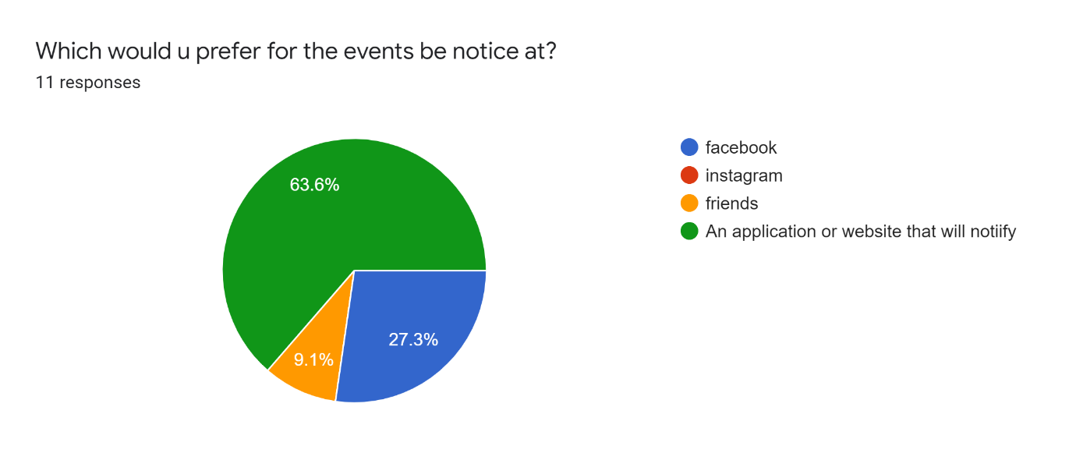

Q6

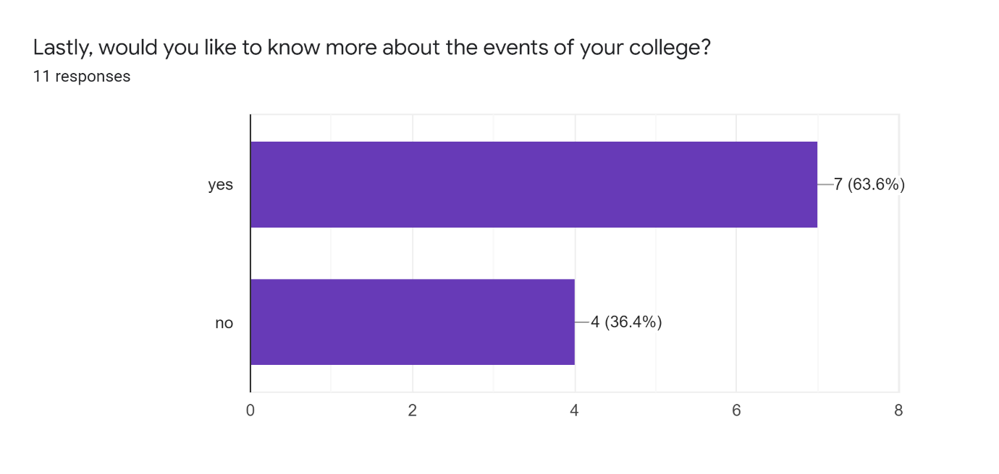

This is my user Story Mapping for my college event system

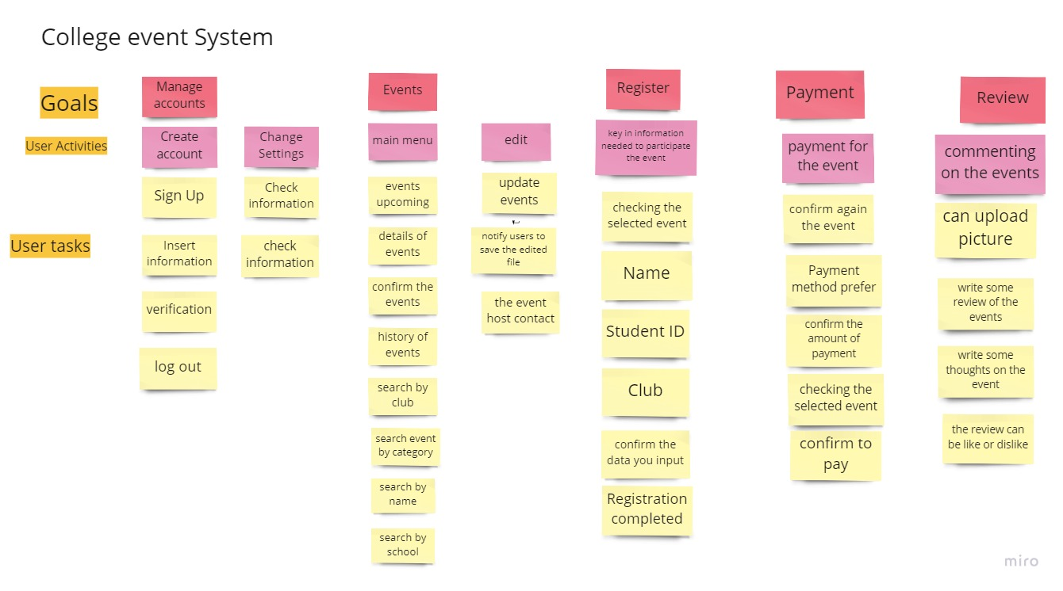

Vision

What is the problem?

From the survey that I conducted, the problem that is pointed out is that the events upcoming most of my respondent knew from social media which is Instagram, Facebook and other social media. Other than that, they also learn about the events that will be held via their friend giving them information on the events. So the problem will be the events that will be held or upcoming is less notice or inform to the student.

As to solving the problem is by design an develop an app that can notify students of the campus and also allow updating the events so that the students is up to date on the events that will be held at campus. Furthermore, from the survey that I’ve done it shows that most of my respondent also prefer having an application in their phone or laptop can notify them on their club event and campus events.

Who are the users?

The users will be the students, teachers and the staff of the campus. Since the application would be used for notify, updating, and browsing through the history of events this application users targeted would be students, teachers and the staff of the campus and also the public if needed.